FANTASY

PREMIER

LEAGUE



10.5.2019

RISHABH SHRIVASTAVA

DEEPAK GOPALAN

KEERTI MURUGAN

PRIYANKA BANDEKAR

DHANASHREE PATIL

**OVERVIEW**

The objective of this system is to build a fantasy premier league game played by nearly 7 million users worldwide, where they will have a budget of $100.0m to spend on an initial squad of 15 players. A squad consists of two goalkeepers, five defenders, five midfielders and three forwards. A maximum of three players can be chosen from anyone Premier League club.

**DATABASE DESIGN AND SPECIFICATIONS**

**Manager:**

Managers must choose a starting 11 players from their 15-man squad before each Gameweek deadline. The formation includes one goalkeeper, at least three defenders, at least two midfielders and at least one forward. Every FPL team's points for the Gameweek will be scored by their 11 starting players but if a starting player does not feature for their club, the points scored by the first player on your bench will automatically be counted instead. Managers must choose a captain and a vice-captain for the Gameweek within the 11 players. A captain's score is doubled, but if the selected skipper does not play in the Gameweek then the vice-captain's score is doubled instead. The same process occurs if two or three starting players fail to appear for their teams. Managers should therefore rank their substitutes in order of preference, to ensure that their first-choice reserve player is first in line.

**Leagues:**

After entering their squad into the game, managers can join and create leagues to compete with their friends and others across the world. There are two types of leagues namely: Private and Public leagues. Private leagues are where you compete against your friends by just creating a league and then send out the unique code to allow your friends to join in. A person can compete in up to 20 private leagues. There is no limit on the number of teams in a single league. Managers can also join a public league of 20 randomly assigned teams where a person can compete in up to three public leagues.

**Making transfers:**

After the first deadline of the season has passed, managers are given one free transfer for each Gameweek. This enables them to sign a player in exchange for a member of their 15-man squad, as long as the switch is within their budget. If managers want to make additional transfers in a Gameweek, they will lose four points for each transfer. If managers do not use their free transfer, they can carry it over and have two free transfers for the following Gameweek.

**Player prices:**

Every player price gets updated during the entire season depending on their popularity among all the managers in the game. For example, a player whose initial price is £6.0m and is transferred into a significant number of teams could gradually rise to £6.5m, or even higher depending upon the popularity of that player. Managers who own the player while his price is increasing will make a profit if they sell him at the higher price. However, they must pay a sell-on fee of 50 per cent, rounded down to the nearest £0.1m. So in the example of the player above who has risen from £6.0m to £6.5m, managers would receive £6.2m when transferring him out.

**1**

**ER DIAGRAM**

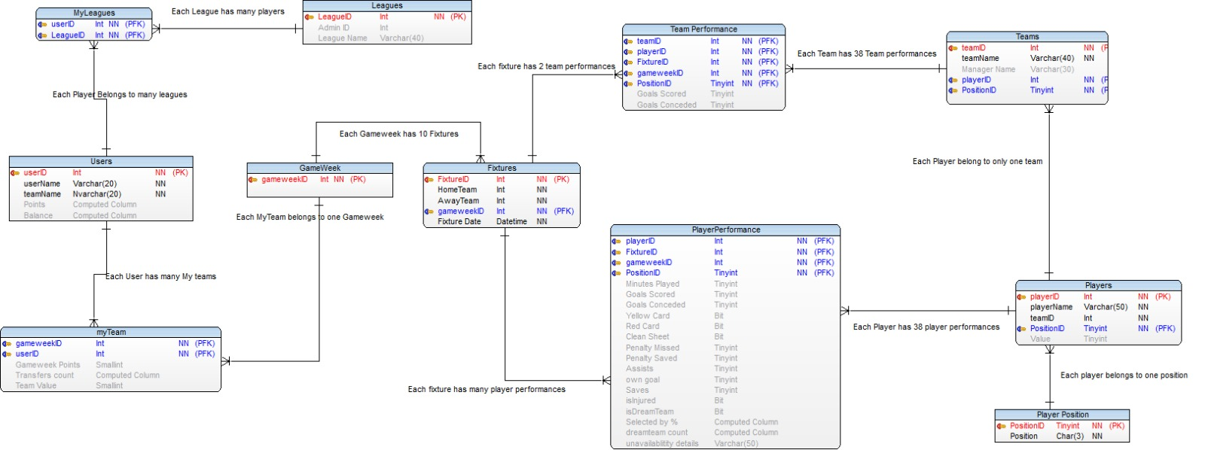

**ENTITIES**

**Leagues**: Contains information about the number of leagues present in the FPL.

**Myleagues**: Contains information about the userID and LeagueID.

**User**: Contains information about the userName and teamName.It has all the data of the user.

**Fixtures:** It has all the report of the FPL matches which are going to take in a league.

**Team**: Contains teamID, PlayerID . It also has information about the PostitonID of the player.

**Team performance**: Contains data about the performance of the player. It has attributes like teamID, playerID, fixtureID, userID, PositionID, gameweek().

**Player**: Contains about the PlayerID, PlayerName, teamID and positionID.

**Player performance**: It is used to calculate the performance of the player using attributes like PlayerID, PositionID, GameWeek().

**PlayerPosition :** It contains information about the position of the player like Goalkeeper, Defender, Mid-Fielder or Forward.

**GameWeek:** Every week there will be a game between different teams

**2**

**ER diagram contains following relationships:**

|  |  |  |
| --- | --- | --- |
| **ENTITY1** | **Entity2** | **CARDINALITY** |
| **User** | **Leagues** | **1:M** |
| **User** | **MyTeam** | **1:M** |
| **Fixture** | **PlayerPerformance** | **1:M** |
| **Fixture** | **TeamPerformance** | **1:M** |
| **MyTeam** | **GameWeek** | **1:1** |
| **League** | **Players** | **1:M** |
| **Player** | **Team** | **1:1** |
| **Player** | **Position** | **1:1** |

|  |  |  |
| --- | --- | --- |
| **Type of Binary relationship** | | **Relationship in a system** |
| **One to One** | 1. Each player belong to one position 2. Each Myteam belongs to one Gameweek 3. Each player belong to one team only | |
| **One to Many** | 1. League has multiple leagues and one user can play any number of leagues. 2. Each fixture has many player performance 3. Player contains the position of the player and also how the player performance would be calculated after the match. | |

3